***Programme1***

***Aim:*** Write a c program to open a file and write some text and close its.

***Code:***

#include <stdio.h>

#include <stdlib.h>

int main()

{

int num;

FILE *fptr;

fptr = fopen("tarun.txt","w");

printf("Enter num: ");

scanf("%d",&num);

fprintf(fptr,"%d",num);

fclose(fptr);

return 0;

}

***Output:***

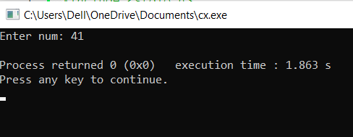

***Programme2***

***Aim:*** Write a c program to delete a file.

***Code:***

#include<stdio.h>

#include<stdlib.h>

int main()

{

int status;

char file[100];

printf("Enter the file address:");

gets(file);

remove(file);

return 0;

***}***

***Output:***

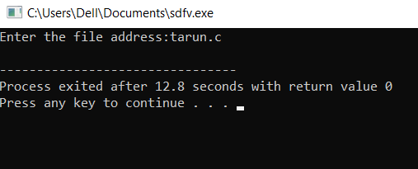

***Programme3***

***Aim***: Write a c program to copy a file from one location to other location.

***Code:***

#include <stdio.h>

#include <stdlib.h>

int main()

{

char ch, source_file[20], target_file[20];

FILE *source, *target;

printf("Enter name of file to copy\n");

gets(source_file);

source = fopen(source_file, "r");

if (source == NULL)

{

printf("Press any key to exit...\n");

exit(EXIT_FAILURE);

}

printf("Enter name of target file\n");

gets(target_file);

target = fopen(target_file, "w");

if (target == NULL)

{

fclose(source);

printf("Press any key to exit...\n");

exit(EXIT_FAILURE);

}

while ((ch = fgetc(source)) != EOF)

fputc(ch, target);

printf("File copied successfully.\n");

fclose(source);

fclose(target);

return 0;

}

***Output:***

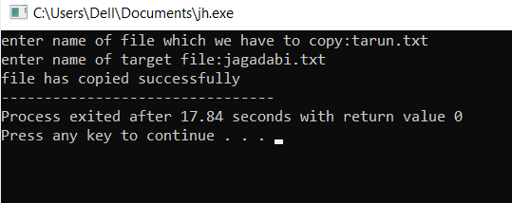

***Programme4***

***Aim:*** Write a c program to copy a data of file to other file.

***Code:***

#include <stdio.h>

#include <stdlib.h>

int main()

{

FILE *fptr1, *fptr2;

char file[100], c;

printf("enter the filename to read:");

scanf("%s", file);

// Open one file for reading

fptr1 = fopen(file, "r");

if (fptr1 == NULL)

{

printf("Cannot open file %s \n", file);

exit(0);

}

printf("enter the filename to write:");

scanf("%s", file);

// Open another file for writing

fptr2 = fopen(file, "w");

if (fptr2 == NULL)

{

printf("cannot open file %s \n", file);

exit(0);

}

// Read contents from file

c = fgetc(fptr1);

while (c != EOF)

{

fputc(c, fptr2);

c = fgetc(fptr1);

}

printf("contents copied suceesfully to %s", file);

fclose(fptr1);

fclose(fptr2);

return 0;

}

***Output:***

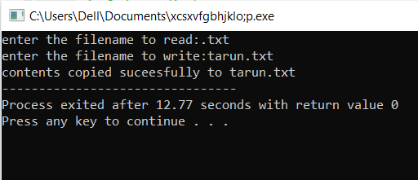

***Programme5***

***Aim:*** To write a c program which display source code as a output.

***Code:***

#include <stdio.h>

#include<stdlib.h>

int main()

{

//file pointer

FILE *fp = NULL;

int ch = 0;

//open the file

fp = fopen(__FILE__, "r");

if(fp == NULL)

{

printf("error in opening the file:");

exit(1);

}

//read till EOF

do

{

ch = fgetc(fp);

printf("%c",ch);

}

while (ch != EOF);

//close open file

fclose (fp);

return 0;

}

***Output:***

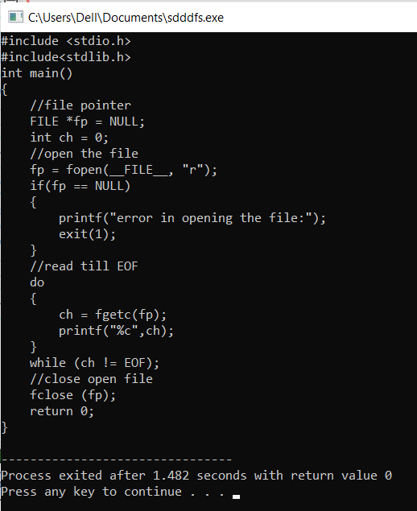

***Programme6***

***Aim:*** Write a c program which writes string in the file.

***Code:***

#include <stdio.h>

int main()

{

FILE *fp;

char file[100];

char writestr[100];

printf("enter the filename:");

gets(file);

printf("enter the string to write:");

gets(writestr);

fp = fopen(file,"w+");

if ( fp )

{

fputs(writestr,fp);

}

else

{

printf("process failed to open a file");

}

fclose(fp);

return(0);

}

***Output:***

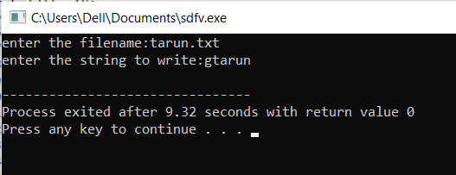

***Programme7  
Aim:*** Write a c program which reads string from file.

***Code:***

#include <stdio.h>

#include <stdlib.h>

int main()

{

char ch, file_name[100];

FILE *fp;

printf("Enter the name of file:");

gets(file_name);

fp = fopen(file_name, "r");

if (fp == NULL)

{

perror("error while opening the file\n");

exit(EXIT_FAILURE);

}

printf("The contents of %s file are:\n", file_name);

while((ch = fgetc(fp)) != EOF)

printf("%c", ch);

fclose(fp);

return 0;

}

***Output:***

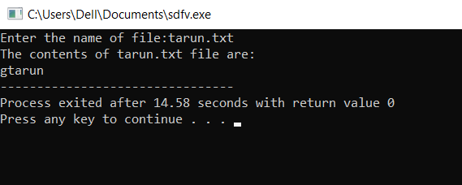

***Programme8***

***Aim:*** Write a c program which writes array in the file.

***Code:***

#include<stdio.h>

#include<stdlib.h>

#define MAX_SIZE 100 // Maximum array size

int main()

{

FILE *p;

int size, i;

int arr[MAX_SIZE];

printf("Enter size of array: ");

scanf("%d", &size);

if((p=fopen("myfile.dat","wb"))==NULL){

printf("Unable to open file myfile.dat");

exit(1);

}

printf("Enter the values:\n");

for(i=0;i<size;i++)

scanf("%d",&arr[i]);

fwrite(arr,sizeof(arr),1,p);

fclose(p);

return 0;

}

***Output:***

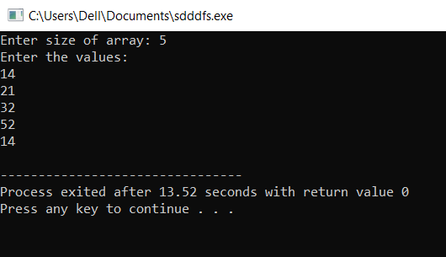

***Programme9***

***Aim:*** Write a c program which concatenate two file and write it third file.

***Code:***

#include <stdio.h>

#include <stdlib.h>

int main()

{

FILE *firstFile1;

FILE *secondFile2;

FILE *destFile;

char firstPath1[100];

char secondPath2[100];

char destPath[100];

char ch;

printf("enter first source file path:");

scanf("%s", firstPath1);

printf("enter second source file path: ");

scanf("%s", secondPath2);

printf("enter destination file path: ");

scanf("%s", destPath);

firstFile1 = fopen(firstPath1, "r");

secondFile2 = fopen(secondPath2, "r");

destFile = fopen(destPath, "w");

if (firstFile1 == NULL || secondFile2 == NULL || destFile == NULL)

{

printf("\nUnable to open file.\n");

printf("Please check if file exists and you have read/write privilege.\n");

exit(EXIT_FAILURE);

}

while ((ch = fgetc(firstFile1)) != EOF)

fputc(ch, destFile);

while ((ch = fgetc(secondFile2)) != EOF)

fputc(ch, destFile);

printf(" both files merged to '%s'.\n", destPath);

fclose(firstFile1);

fclose(secondFile2);

fclose(destFile);

return 0;

}

***Output:***

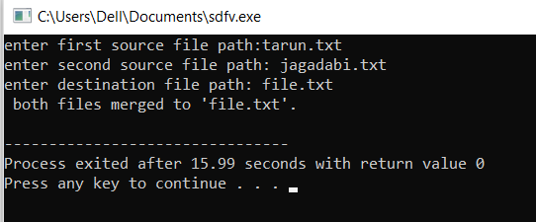

***Programme10***

***Aim:*** Write a c program to find out size of any file.

***Code:***

#include <stdio.h>

long int findSize(char file_name[])

{

FILE* fp = fopen(file_name, "r");

if (fp == NULL) {

printf("File Not Found!\n");

return -1;

}

fseek(fp, 0L, SEEK_END);

long int res = ftell(fp);

fclose(fp);

return res;

}

int main()

{

char file_name[] = { "tarun.txt" };

long int res = findSize(file_name);

if (res != -1)

printf("Size of the file is %ld bytes \n", res);

return 0;

}

***Output:***

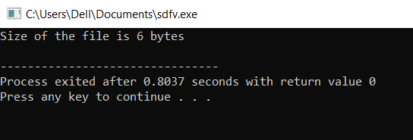

***Programme11***

***Aim:*** Write a c program to know type of file.

***Code:*** #include "time.h"

#include "sys\stat.h"

#include "stdio.h"

void main(){

struct stat status;

FILE *fp;

stat("c:\\tc\\bin",&status);

clrscr();

if (status.st_mode & S_IFDIR)

printf("It is directory.\n");

if (status.st_mode & S_IFCHR)

printf("It is chracter file.");

if (status.st_mode & S_IFREG)

printf("It is reggular file.");

getch();

}

***Output:***

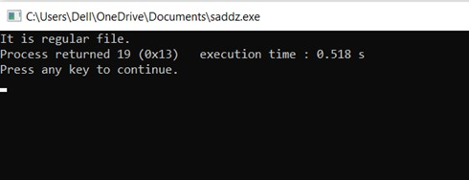

***Programme12***

***Aim:*** Write a c program to know permission of any file.

***Code:***

#include "time.h"

#include "sys\stat.h"

#include "stdio.h"

void main(){

struct stat status;

FILE *fp;

stat("test.txt",&status);

clrscr();

if (status.st_mode & S_IREAD)

printf("You have read permission.\n");

if (status.st_mode & S_IWRITE)

printf("You have write permission.");

getch();

}

***Output:***

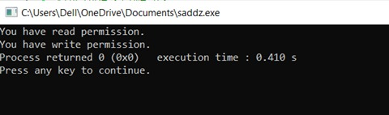

***Programme13***

***Aim:*** Write a c program to know last date of modification of any file.

***Code:***

#include<stdio.h>

#include <time.h>

#include <sys\stat.h>

int main()

{

struct stat status;

FILE *fp;

fp=fopen("tarun.txt","r");

fstat(fileno(fp),&status);

printf("last date of modification: %s",ctime(&status.st_ctime));

return 0;

}

***Output:***

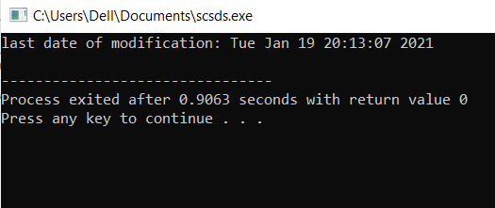

***Programme14***

***Aim:*** Write a c program to find size and drive of any file.

***Code:***

#include<stdio.h>

#include<time.h>

#include<sys\stat.h>

int main()

{

struct stat status;

FILE *fp;

fp=fopen("tarun.txt","r");

fstat(fileno(fp),&status);

printf("size of file : %d\n",status.st_size);

printf("drive name : %c",65+status.st_dev);

return 0;

}

***Output:***

